GDP: Measuring Total Production and Income

Name
Institution of Affiliation
Professor
Date

GDP: Measuring Total Production and Income
According to Raymond Zhong (2016), the economy of India expanded rapidly in 2015 than any other economy in the world. This was the first time this economy grew very fast in the 20 years. However, the statistics on the country's GDP are not fully reliable since most workers are in the informal sector which is not recorded when computing the national product and the operational businesses are not registered as they are considered to be small. The government is also not frequent in collecting data about the value-added to products in the market and other cash-generating points in the country. The GDP figures thus in India are less of measurement than an estimate.
Raymond further states that the GDP numbers in India are closely monitored since 2015 since the figures shot following the revision of GDP estimation methods. The shooting of the figure was not consistent with the GDP indicators such as the cargo traffic and exports, a fact that gave mixed signals about the performance of the economy.
The wholesale price index that has been in place for measuring the trend of prices in the economy has many shortfalls like its inconsistence with the retail price. The wholesale price index shows a declining trend while the retail price is increasing. The wholesale price index, however, will remain to be used to measure inflation until an efficient method is found.
The availability of data on services considered small-term is a challenge. The government uses revenue from tax and sales as an estimator for the amount such sectors contribute since it measures their actual contribution inconsistently and after a long while. The contribution from large corporations is also estimated as most of such institutions post their financial statements late as well as altering them to hide the actual profits earned by them (Raymond Zhong, 2016).
The GDP figures thus given by the statistics offices in India are mere estimates that have been extrapolated from insufficient data gathered from a few sources. They can not be fully relied on to give the true picture of the economic performance in the country.
This article by Raymond Zhong is a whistleblower to the government and the authorities responsible for GDP measurements. For the figures to count, the authorities need to collect enough data for analysis and come up with true results from the findings rather than merely approximating.
GDP is not a good indicator of the welfare of the citizens of a country (Podger & Trewin, 2014). This is because it does not include leisure time which is essential for any working individual. Only the transactions in the market are included. The operations of the shadow market, which sometimes earn their operators more than even the formal market operations, are not included in the GDP calculations. The distribution of income is not indicated in GDP figures. The measurement just gives the general figure without indicating the amount owned by each individual. This figure could give the wrong picture as the wealth in a country could be owned by a few individuals as a larger percentage languishes in poverty. Details about what is produced are also not given. The details about the value-added to products at each stage are not included. GDP also does not include externalities to the national production like the earthquakes and outbreak of pandemics like the current Covid-19.
Income increases as total production increases. An increase in total production increases the per capita income of a country thus income. The graph below shows the per capita income of India since 1984. The economy of India can be described to be growing over the years. This is according to the report given by the World Bank (2000).
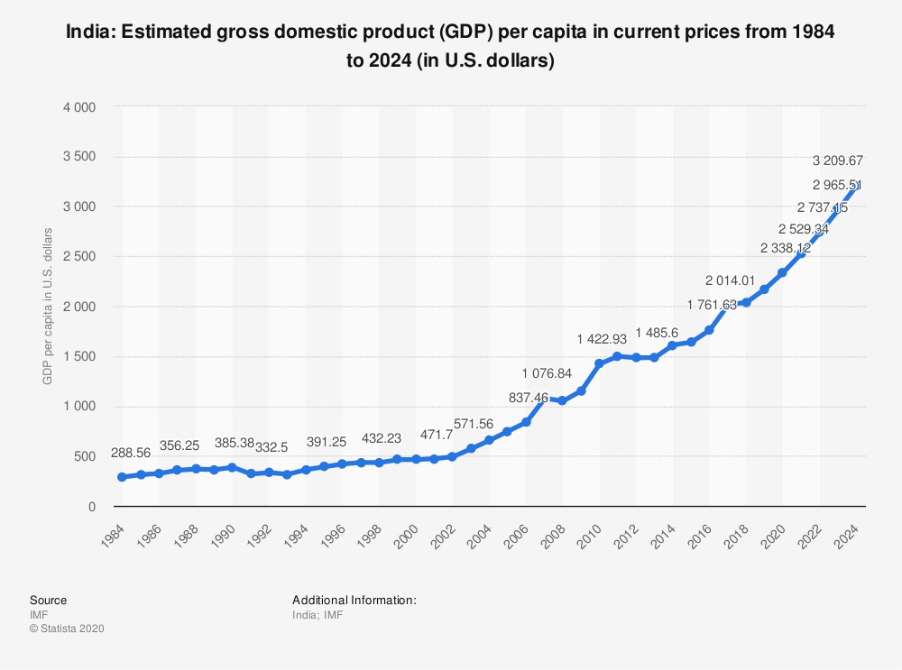
Figure 1 India's GDP estimation from the year 1984 to 2024, (IMF)
The term 'off the books' used by Raymond Zhong (2016) in the article means that some of the workers are not recorded to be working. They are considered to be unemployed yet they are working. This means that their wages and salaries are not included in the figures used to estimate the national product.
If the government cannot measure GDP accurately, the true figure of revenue earned by the businesses and their total contribution to the growth of the economy cannot be measured accurately. The living standards of the individuals thus may be overestimated or underestimated.
The firms in the informal sector are usually small compared to their counterparts in the formal sector. The firms opt to remain small to avoid being monitored by the government and revenue authorities. The large firms are usually taxed since they are considered to make large profits. The small firms may be ignored since their contribution is considered to be minimal.
In conclusion, we can say that in order for the GDP figures to be a true reflection of standards of living, correct data should be gathered and true measures that include the value added to products is used. Some countries will always be better off in terms of welfare than others even if the per capita income is equal.

References
Beyond GDP Conference. <2007, Bruxelles>., & Europäische Kommission. (2009). Beyond GDP: Measuring progress, true wealth, and the well-being of nations; 19-20 November 2007, European Parliament, Brussels; conference proceedings. Luxembourg: Office for Official Publ. of the Europ. Communities.
Podger, A., & Trewin, D. (2014). Measuring and Promoting Wellbeing: How Important Is Economic Growth?. Canberra: ANU Press.
World Bank. (2000). India: Reducing poverty, accelerating development. New Delhi, India: Oxford University Press.

